**White Box Testing**

**Testing Method:** Basis Path Testing

**Use case: Bookmark**

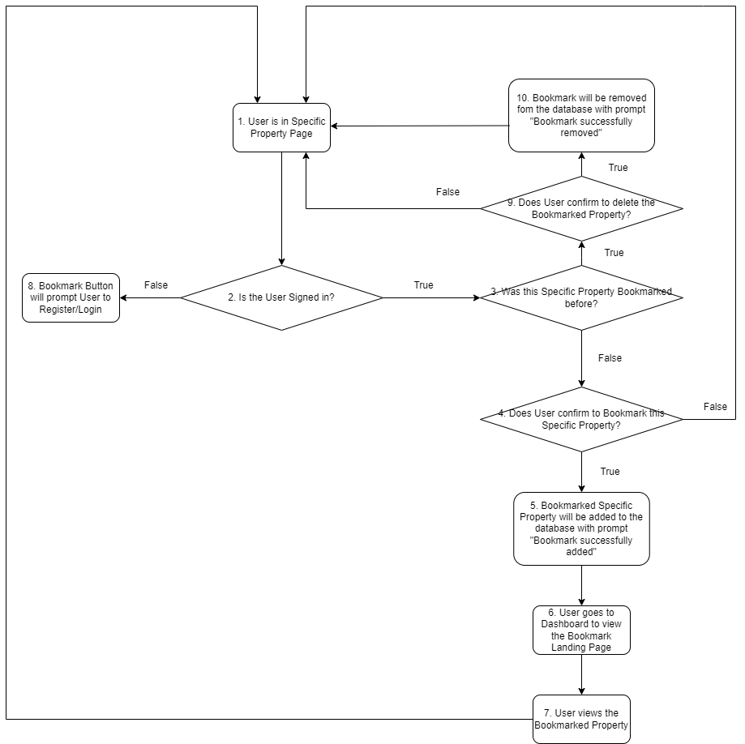

**Control Flow Graph**

|  |  |  |
| --- | --- | --- |
| **No.** | **Set of Basis Path** | **Test Cases** |
| **1** | 1-2-3-4-5-6-7-1 | 1. User is signed in 2. User has not bookmarked the property before 3. User bookmarks the property |
| **2** | 1-2-8 | 1. User is not signed in |
| **3** | 1-2-3-4-1 | 1. User is signed in 2. User has not bookmarked the property before 3. User does not bookmark the property |
| **4** | 1-2-3-9-10-1 | 1. User is signed in 2. Property has been bookmarked before 3. User deletes the bookmarked property |
| **5** | 1-2-3-9-1 | 1. User is signed in 2. Property has been bookmarked before 3. User does not delete the bookmarked property |

**Test Case 1: User signed in + Property not bookmarked + User confirms bookmark**

**Test Path 1: 1-2-3-4-5-6-7-1**

|  |  |  |  |  |
| --- | --- | --- | --- | --- |
| **No.** | **Prerequisite** | **Action** | **Expected Output** | **Actual Output** |
| **1** | User is signed in, Property is not bookmarked | User clicks on confirm bookmark button | Prompt for “Bookmark successfully added” is shown. User is redirected to a specific property landing page. | Prompt for “Bookmark successfully added” is shown. User is redirected to a specific property landing page. |

**Test Case 2: User is not signed in**

**Test Path 2: 1-2-8**

|  |  |  |  |  |
| --- | --- | --- | --- | --- |
| **No.** | **Prerequisite** | **Action** | **Expected Output** | **Actual Output** |
| **2** | User is not signed in | User clicks on bookmark button | User is redirected to Register page | User is redirected to Register page |

**Test Case 3: User signed in + Property not bookmarked + User does not bookmark property**

**Test Path 3: 1-2-3-4-1**

|  |  |  |  |  |
| --- | --- | --- | --- | --- |
| **No.** | **Prerequisite** | **Action** | **Expected Output** | **Actual Output** |
| **3** | User is signed in, property is not bookmarked before | User clicks on cancel bookmark button | User will be redirected to specific property landing page | User will be redirected to specific property landing page |

**Test Case 4: User signed in + Property bookmarked + User removes bookmark**

**Test Path 4: 1-2-3-9-10-1**

|  |  |  |  |  |
| --- | --- | --- | --- | --- |
| **No.** | **Prerequisite** | **Action** | **Expected Output** | **Actual Output** |
| **4** | User is signed in, Property is bookmarked. | User clicks on delete bookmark button and confirms | “Bookmark successfully removed” prompt shown.  User is redirected to specific property landing page | “Bookmark successfully removed” prompt shown.  User is redirected to specific property landing page |

**Test Case 5: User signed in + Property bookmarked + User cancels deletion prompt**

**Test Path 5: 1-2-3-9-1**

|  |  |  |  |  |
| --- | --- | --- | --- | --- |
| **No.** | **Prerequisite** | **Action** | **Expected Output** | **Actual Output** |
| **5** | User is signed in, Property is bookmarked. | User clicks on delete bookmark button and cancels | User is redirected to specific property landing page | User is redirected to specific property landing page |

**Use Case: Search**

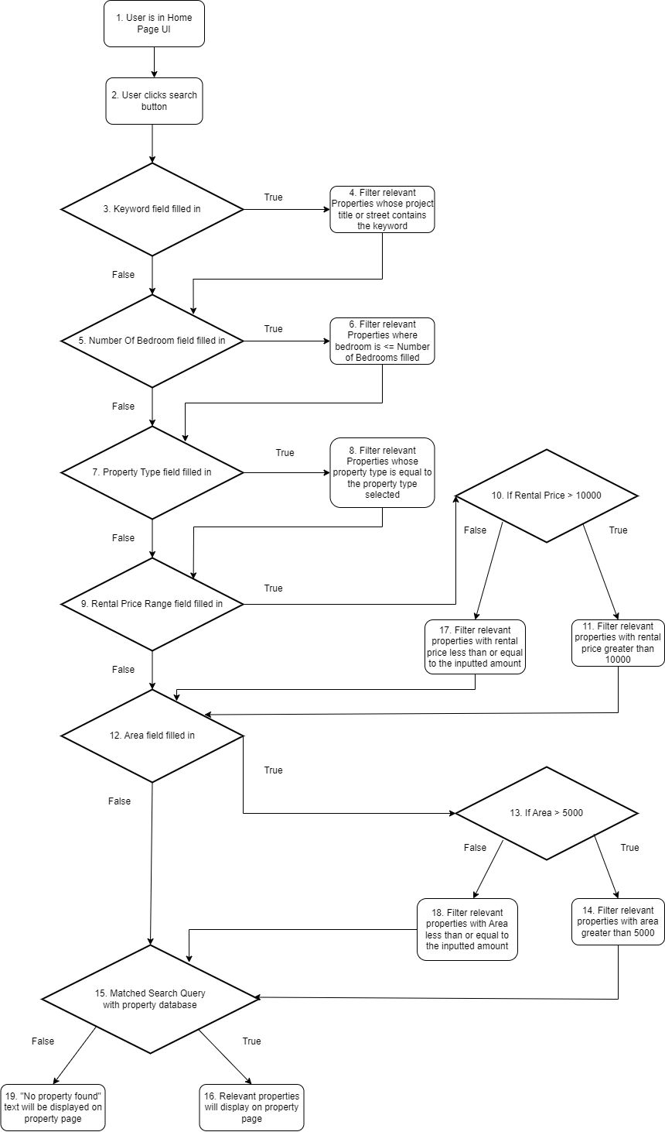

**Control Flow Graph**

|  |  |  |
| --- | --- | --- |
| **No.** | **Set of Basis Path** | **Test Cases** |
| **1** | 1-2-3-4-5-6-7-8-9-10-17-12-13-18-15-16 (Matched) | 1. Keyword is filled in: ‘paya lebar’ 2. Number of Bedroom is filled in: <=10 3. Property type is filled in: Non-Landed 4. Rental Price Range is filled in: <= $10,000 5. Area is filled in: <= 5000 Sqft |
| **2** | 1-2-3-5-6-7-8-9-10-17-12-13-18-15-16 (Matched) | 1. Keyword is not filled in 2. Number of Bedroom is filled in: <=10 3. Property type is filled in: Non-Landed 4. Rental Price Range is filled in: <= $10,000 5. Area is filled in: <= 5000 Sqft |
| **3** | 1-2-3-4-5-7-8-9-10-17-12-13-18-15-16 (Matched) | 1. Keyword is filled in: ‘paya lebar’ 2. Number of Bedroom is not filled in 3. Property type is filled in: Non-Landed 4. Rental Price Range is filled in: <= $10,000 5. Area is filled in: <= 5000 Sqft |
| **4** | 1-2-3-4-5-6-7-9-10-17-12-13-18-15-16 (Matched) | 1. Keyword is filled in: ‘paya lebar’ 2. Number of Bedroom is filled in: <=10 3. Property type is not filled in 4. Rental Price Range is filled in: <= $10,000 5. Area is filled in: <= 5000 Sqft |
| **5** | 1-2-3-4-5-6-7-8-9-12-13-18-15-16 (Matched) | 1. Keyword is filled in: ‘paya lebar’ 2. Number of Bedroom is filled in: <=10 3. Property type is filled in: Non-Landed 4. Rental Price Range is not filled in 5. Area is filled in: <= 5000 Sqft |
| **6** | 1-2-3-4-5-6-7-8-9-10-17-12-15-16 (Matched) | 1. Keyword is filled in: ‘paya lebar’ 2. Number of Bedroom is filled in: <=10 3. Property type is filled in: Non-Landed 4. Rental Price Range is filled in: <= $10,000 5. Area is not filled in |
| **7** | 1-2-3-4-5-6-7-8-9-10-11-12-13-18-15-16 (Matched) | 1. Keyword is filled in: ‘cliveden’ 2. Number of Bedroom is filled in: <=10 3. Property type is filled in: Non-Landed 4. Rental Price Range is filled in: $10,000 + 5. Area is filled in: <= 5000 Sqft |
| **8** | 1-2-3-4-5-6-7-8-9-10-17-12-13-14-15-16 (Matched) | 1. Keyword is filled in: ‘springleaf’ 2. Number of Bedroom is filled in: <=10 3. Property type is filled in: Semi-Detached 4. Rental Price Range is filled in: <= $10,000 5. Area is filled in: 5000 Sqft+ |
| **9** | 1-2-3-4-5-6-7-8-9-10-17-12-13-18-15-19 (Not Matched) | 1. Keyword is filled in: ‘qweqwe’ 2. Number of Bedroom is filled in: <=10 3. Property type is filled in: Non-Landed 4. Rental Price Range is filled in: <= $10,000 5. Area is filled in: <= 5000 Sqft |

**Test Case 1: All Search Fields Filled In**

**Test Path 1:** 1-2-3-4-5-6-7-8-9-10-17-12-13-18-15-16 (Matched)

|  |  |  |  |  |
| --- | --- | --- | --- | --- |
| **No.** | **Action** | **Input** | **Expected Output** | **Actual Output** |
| **1** | - Enter keywords, select no of bedrooms, property type, rent, area  - Click Submit Form | - Keyword input: ‘paya lebar’  - No. of Bedroom input: <= 10  - Property type input: Non-Landed  - Rental Price Range input: <= $10,000  - Area Input: <= 5000 Sqft | List of properties matching search query will be displayed on the property page. | List of properties matching search query will be displayed on the property page. |

**Test Case 2: All search fields except for keyword is filled in**

**Test Path 2:** 1-2-3-5-6-7-8-9-10-17-12-13-18-15-16 (Matched)

|  |  |  |  |  |
| --- | --- | --- | --- | --- |
| **No.** | **Action** | **Input** | **Expected Output** | **Actual Output** |
| **2** | - Select no of bedrooms, property type, rent, area  - Click Submit Form | - Keyword is not filled in  - No. of Bedroom input: <= 10  - Property type input: Non-Landed  - Rental Price Range input: <= $10,000  - Area Input: <= 5000 Sqft | List of properties matching search query will be displayed on the property page. | List of properties matching search query will be displayed on the property page. |

**Test Case 3: All search fields except for number of bedrooms is filled in**

**Test Path 3:** 1-2-3-4-5-7-8-9-10-17-12-13-18-15-16 (Matched)

|  |  |  |  |  |
| --- | --- | --- | --- | --- |
| **No.** | **Action** | **Input** | **Expected Output** | **Actual Output** |
| **3** | - Enter Keyword, select property type, rent, area  - Click Submit Form | - Keyword input: ‘paya lebar’  - Number of Bedroom is not filled in  - Property type input: Non-Landed  - Rental Price Range input: <= $10,000  - Area Input: <= 5000 Sqft | List of properties matching search query will be displayed on the property page. | List of properties matching search query will be displayed on the property page. |

**Test Case 4: All search fields except for property type is filled in**

**Test Path 4:** 1-2-3-4-5-6-7-9-10-17-12-13-18-15-16 (Matched)

|  |  |  |  |  |
| --- | --- | --- | --- | --- |
| **No.** | **Action** | **Input** | **Expected Output** | **Actual Output** |
| **4** | - Enter Keyword, select no of bedrooms, rent, area  - Click Submit Form | - Keyword input: ‘paya lebar’  - No. of Bedroom input: <= 10  - Property type is not filled in  - Rental Price Range input: <= $10,000  - Area Input: <= 5000 Sqft | List of properties matching search query will be displayed on the property page. | List of properties matching search query will be displayed on the property page. |

**Test Case 5: All search fields except for rental price range is filled in**

**Test Path 5:** 1-2-3-4-5-6-7-8-9-12-13-18-15-16 (Matched)

|  |  |  |  |  |
| --- | --- | --- | --- | --- |
| **No.** | **Action** | **Input** | **Expected Output** | **Actual Output** |
| **5** | - Enter Keyword, select no of bedrooms, property type, area  - Click Submit Form | - Keyword input: ‘paya lebar’  - No. of Bedroom input: <= 10  - Property type input: Non-Landed  - Rental Price Range is not filled in  - Area Input: <= 5000 Sqft | List of properties matching search query will be displayed on the property page. | List of properties matching search query will be displayed on the property page. |

**Test Case 6: All search fields except for area is filled in**

**Test Path 6:** 1-2-3-4-5-6-7-8-9-10-17-12-15-16 (Matched)

|  |  |  |  |  |
| --- | --- | --- | --- | --- |
| **No.** | **Action** | **Input** | **Expected Output** | **Actual Output** |
| **6** | - Enter Keyword, select no of bedrooms, property type, rent  - Click Submit Form | - Keyword input: ‘paya lebar’  - No. of Bedroom input: <= 10  - Property type input: Non-Landed  - Rental Price Range input: <= $10,000  - Area is not filled in | List of properties matching search query will be displayed on the property page. | List of properties matching search query will be displayed on the property page. |

**Test Case 7: All search fields filled in and rental price range is > 10000**

**Test Path 7:** 1-2-3-4-5-6-7-8-9-10-11-12-13-18-15-16 (Matched)

|  |  |  |  |  |
| --- | --- | --- | --- | --- |
| **No.** | **Action** | **Input** | **Expected Output** | **Actual Output** |
| **7** | - Enter Keyword, select no of bedrooms, property type, rent, area  - Click Submit Form | - Keyword input: ‘cliveden’  - No. of Bedroom input: <= 10  - Property type input: Non-Landed  - Rental Price Range input: $10,000 +  - Area Input: <= 5000 Sqft | List of properties matching search query will be displayed on the property page. | List of properties matching search query will be displayed on the property page. |

**Test Case 8: All search fields filled in and area is > 5000**

**Test Path 8:** 1-2-3-4-5-6-7-8-9-10-17-12-13-14-15-16 (Matched)

|  |  |  |  |  |
| --- | --- | --- | --- | --- |
| **No.** | **Action** | **Input** | **Expected Output** | **Actual Output** |
| **8** | - Enter Keyword, select no of bedrooms, property type, rent, area  - Click Submit Form | - Keyword input: ‘springleaf’  - No. of Bedroom input: <= 10  - Property type input: Semi-Detached  - Rental Price Range input: <= $10,000  - Area Input: 5000 Sqft + | List of properties matching search query will be displayed on the property page. | List of properties matching search query will be displayed on the property page. |

**Test Case 9: All Search Field Filled and no matches**

**Test Path 9:** 1-2-3-4-5-6-7-8-9-10-17-12-13-18-15-19 (Not Matched)

|  |  |  |  |  |
| --- | --- | --- | --- | --- |
| **No.** | **Action** | **Input** | **Expected Output** | **Actual Output** |
| **9** | - Enter Keyword, select no of bedrooms, property type, rent, area  - Click Submit Form | - Keyword input: ‘qweqwe’  - No. of Bedroom input: <= 10  - Property type input: Non-Landed  - Rental Price Range input: <= $10,000  - Area Input: <= 5000 Sqft | Prompt showing “No property found” displayed on property page. | Prompt showing “No property found” displayed on property page. |